**Innovation in Measuring Water Depth: Arduino Based Sensor Technology**

# OBJECTIVE:

The primary objective of innovation in measuring water depth using Arduino-based sensor technology is to enhance the accuracy, reliability, and efficiency of water level monitoring systems. By leveraging Arduino's capabilities, these systems can provide real-time data, remote monitoring capabilities, and cost-effective solutions for various applications, including:

1. Water Resource Management: Accurately measuring water levels in reservoirs, lakes, and rivers is crucial for effective water resource management. Arduino-based sensors can provide real-time data on water levels, enabling better water allocation, conservation strategies, and flood risk assessment.
2. Agriculture and Irrigation: Precise water level monitoring is essential for efficient irrigation practices in agriculture. Arduino-based sensors can optimize irrigation schedules, reduce water wastage, and improve crop yields.
3. Industrial Applications: Accurate water level measurement is critical for various industrial processes, such as chemical mixing, tank filling, and wastewater treatment. Arduino-based sensors can provide real-time data for process control, ensuring product quality and environmental compliance.
4. Domestic and Commercial Use: Monitoring water levels in tanks, reservoirs, and wells is important for domestic and commercial applications. Arduino-based sensors can provide alerts when water levels are low or high, preventing water shortages or overflow situations.
5. Environmental Monitoring: Water level monitoring is crucial for understanding and managing ecosystems. Arduino-based sensors can provide data on water levels in wetlands, estuaries, and coastal areas, aiding in environmental research and conservation efforts.

The innovation in measuring water depth using Arduino-based sensor technology offers several advantages over traditional methods:

1. Cost-Effectiveness: Arduino-based systems are relatively inexpensive to build and maintain, making them accessible to a wider range of users.
2. Accuracy and Reliability: Arduino-based sensors can provide accurate measurements of water depth, even in challenging environments.
3. Real-Time Data: Arduino-based systems can provide real-time data on water levels, enabling immediate response to changes.
4. Remote Monitoring: Arduino-based systems can be connected to networks, allowing for remote monitoring of water levels from anywhere in the world.
5. Versatility: Arduino-based systems can be customized to suit specific applications and sensor types, making them adaptable to various needs.

As Arduino-based sensor technology continues to evolve, its applications in water depth measurement are expected to expand further, contributing to improved water resource management, environmental protection, and sustainable practices across various sectors.

# ABSTRACT:

Arduino-based sensor technology is revolutionizing water depth measurement by providing accurate, real-time data and enabling remote monitoring capabilities. This innovation offers a cost-effective and versatile solution for various applications, including water resource management, agriculture, industrial processes, domestic and commercial use, and environmental monitoring.

Arduino-based systems are replacing traditional methods due to their ease of use, adaptability, and ability to integrate with various sensor types. This technology is transforming water depth measurement by providing reliable data for informed decision-making and efficient resource management.

The advancements in Arduino-based sensor technology are paving the way for improved water conservation, sustainable practices, and enhanced environmental protection. As this technology continues to evolve, its impact on water depth measurement and its applications will undoubtedly_expand_further.

# INTRODUCTION:

Accurately measuring water depth is essential for various applications, including water resource management, agriculture, industrial processes, domestic use, and environmental monitoring. Traditional methods of water depth measurement, such as manual measurements and float-based sensors, often face limitations in terms of accuracy, reliability, and efficiency. Arduino-based sensor technology has emerged as a promising alternative, offering cost-effective, accurate, and real-time solutions for water depth monitoring.

Arduino is an open-source electronics platform based on easy-to-use hardware and software. It allows users to create interactive electronic objects by connecting hardware components, such as sensors, actuators, and LEDs, to a microcontroller board. Arduino's ease of use and affordability have made it a popular choice for hobbyists, educators, and professionals alike.

**How Arduino-Based Sensors Measure Water Depth**

Arduino-based sensor systems can utilize various sensor types to measure water depth. Ultrasonic sensors are commonly used due to their accuracy and non-contact measurement capabilities. These sensors emit ultrasonic pulses that bounce off the water surface. The time it takes for the pulse to return to the sensor is used to calculate the distance to the water surface, which in turn provides the water depth.

# HARDWARE/SOFTWARE REQUIREMENTS:

**Hardware Requirements**

* Arduino Uno microcontroller board
* Ultrasonic sensor (HC-SR04 or similar)
* Breadboard
* Jumper wires
* Computer with Arduino IDE software installed

[Opens in a new window](https://www.indiamart.com/proddetail/hc-sr04-ultrasonic-sensor-18101779448.html)

chevron_right[www.indiamart.com](http://www.indiamart.com)

Ultrasonic sensor HCSR04

**Additional Hardware (Optional)**

* LCD display
* GSM module
* WiFi module
* Power supply (battery or AC adapter)

**Software Requirements**

* Arduino IDE software
* (Optional) Programming language (C++, Python) for more advanced applications

**Additional Software (Optional)**

* Data visualization software (e.g., Matplotlib, Seaborn)
* IoT platform (e.g., ThingSpeak, Blynk) for remote monitoring and data storage

# CONCEPTS/WORKING PRINCIPLE:

**Concept: Ultrasonic Ranging**

Arduino-based water depth monitoring systems typically utilize ultrasonic sensors to measure the distance to the water surface. Ultrasonic sensors work on the principle of time-of-flight (TOF) measurement. They emit ultrasonic pulses (high-frequency sound waves) that travel through the air until they encounter an obstacle or reflect off a surface. The reflected pulse then travels back to the sensor. The time it takes for the pulse to travel from the sensor to the obstacle and back is used to calculate the distance to the obstacle.

Ultrasonic sensor working principle.Working Principle of Arduino-Based Water Depth Monitoring System An Arduino-based water depth monitoring system typically consists of the following components:

Arduino Uno microcontroller board: This serves as the central processing unit of the system, responsible for controlling the sensor, processing data, and displaying or communicating the results. Ultrasonic sensor (HC-SR04 or similar): This sensor emits and receives ultrasonic pulses, providing the distance information required to calculate water depth.

Breadboard: This provides a platform for connecting the sensor and other components to the Arduino board using jumper wires.

Jumper wires: These are used to connect the Arduino board, sensor, and other components, allowing for easy circuit prototyping. Computer with Arduino IDE software installed: The Arduino IDE is a programming environment used to write and upload code to the Arduino board.

Steps Involved in Measuring Water Depth

Trigger the Ultrasonic Sensor: The Arduino board sends a trigger signal to the ultrasonic sensor, instructing it to emit an ultrasonic pulse.

Measure Pulse Travel Time: The ultrasonic sensor detects the reflected pulse and measures the time it takes to return to the sensor.

Calculate Distance to Water Surface: Using the speed of sound in air and the pulse travel time, the Arduino board calculates the distance to the water surface.

Determine Water Depth: Subtract the distance to the water surface from the distance to the sensor's mounting point to obtain the water depth.

Display or Communicate Water Depth: The Arduino board displays the calculated water depth on an LCD screen or sends it to a remote server or cloud platform for real-time monitoring and data storage.

Additional Considerations

Calibration: To ensure accuracy, the ultrasonic sensor should be calibrated to account for any environmental factors that may affect the speed of sound, such as temperature and humidity.

Data Processing: The Arduino board can perform additional data processing, such as filtering out noise and averaging multiple measurements to improve accuracy.

Communication: The Arduino board can communicate with other devices or networks using various communication protocols, such as WiFi, Bluetooth, or GSM, enabling remote monitoring and data transfer.

Power Supply: The system can be powered by a battery or an AC adapter, depending on the application and portability requirements.

# APPROACH/METHODOLOGY/PROGRAMS:

Approach

The approach for implementing an Arduino-based water depth monitoring system involves the following steps:

Hardware Setup: Assemble the hardware components, including the Arduino board, ultrasonic sensor, breadboard, jumper wires, and any additional components required for power supply, communication, or display.

Sensor Calibration: Calibrate the ultrasonic sensor to ensure accurate distance measurements. This may involve adjusting the sensor's position or accounting for environmental factors that affect the speed of sound.

Programming: Write Arduino code to control the sensor, process data, and display or communicate water depth measurements. The code should include the following functionalities:

a. Triggering the Ultrasonic Sensor: Send a trigger signal to the ultrasonic sensor to initiate the ultrasonic pulse emission.

b. Measuring Pulse Travel Time: Capture the pulse reflection using the sensor's output pin and calculate the pulse travel time.

c. Calculating Distance: Convert the pulse travel time to distance using the speed of sound in air.

d. Calculating Water Depth: Subtract the distance to the water surface from the distance to the sensor's mounting point.

e. Displaying or Communicating Water Depth: Display the calculated water depth on an LCD screen or send it to a remote server or cloud platform for real-time monitoring and data storage.

Testing and Evaluation: Thoroughly test the system to ensure accurate and reliable water depth measurements. This may involve testing in different water conditions and comparing measurements to known reference values.

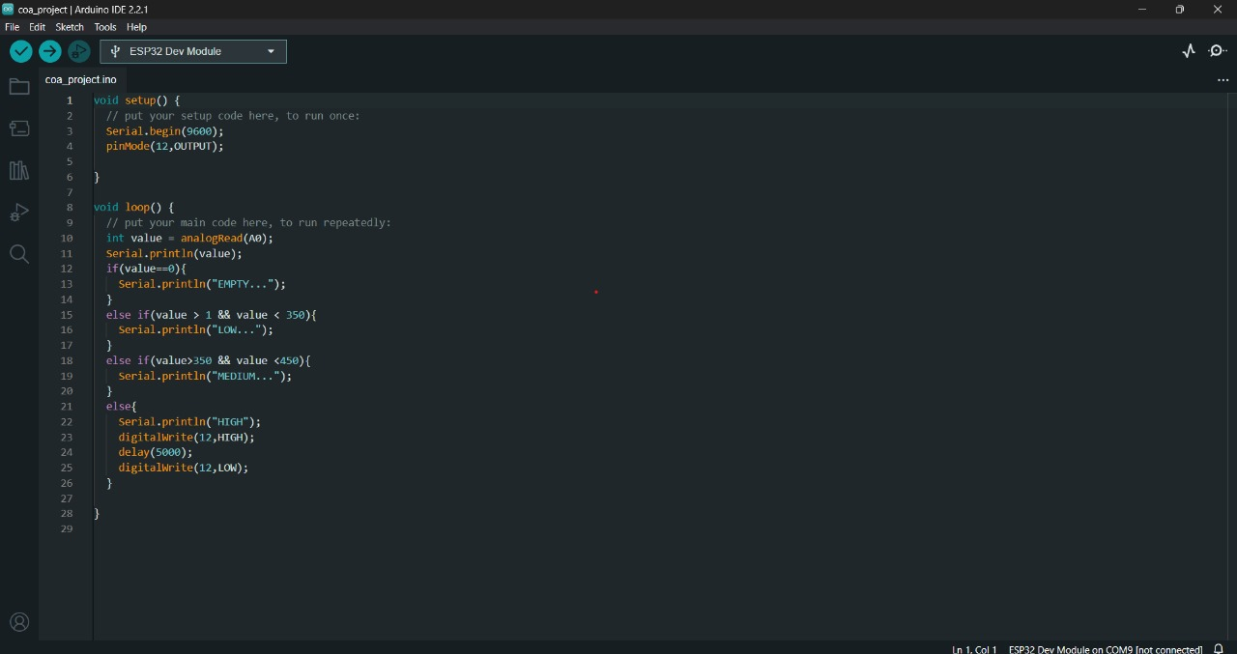

# FLOWCHART:

Start

1. Trigger Ultrasonic Sensor: Send a signal to the ultrasonic sensor to initiate the ultrasonic pulse emission.
2. Measure Pulse Travel Time: Capture the pulse reflection using the sensor's output pin and calculate the pulse travel time.
3. Calculate Distance: Convert the pulse travel time to distance using the speed of sound in air.
4. Calculate Water Depth: Subtract the distance to the water surface from the distance to the sensor's mounting point.
5. Is Water Depth Within Acceptable Range?

a. Yes: Display or communicate the water depth.

b. No: Generate an alert or notification indicating an abnormal water level.

1. End

This flowchart illustrates the core steps involved in measuring water depth using Arduino-based sensor technology. The specific implementation may include additional steps for sensor calibration, data filtering, and error handling.

# CONCLUSIONS:

In conclusion, Arduino-based sensor technology has revolutionized water depth measurement, providing a valuable tool for enhancing water resource management, optimizing irrigation practices, improving industrial processes, ensuring domestic water security, and furthering environmental monitoring efforts. As the technology continues to evolve, its impact is expected to grow, contributing to a more sustainable and water-secure future. here are some key points to summarize the concept of innovation in measuring water depth using Arduino-based sensor technology:

1. The Need for Accurate Water Depth Monitoring

Accurately measuring water depth is essential for various applications, including water resource management, agriculture, industrial processes, domestic use, and environmental monitoring. Traditional methods of water depth measurement often face limitations in terms of accuracy, reliability, and efficiency.

2. Arduino-Based Sensor Technology as a Solution

Arduino-based sensor technology has emerged as a promising alternative for water depth monitoring, offering several advantages over traditional methods:

Cost-effectiveness: Arduino-based systems are relatively inexpensive to build and maintain.

Accuracy and reliability: Arduino-based sensors can provide accurate and reliable water depth measurements.

Real-time data: Arduino-based systems can provide real-time data on water levels.

Remote monitoring: Arduino-based systems can be connected to networks for remote monitoring.

Versatility: Arduino-based systems can be customized to suit specific applications and sensor types.

3. Working Principle of Arduino-Based Water Depth Monitoring Systems

Arduino-based water depth monitoring systems typically utilize ultrasonic sensors to measure the distance to the water surface. The time it takes for an ultrasonic pulse to travel from the sensor to the water surface and back is used to calculate the water depth.

4. Applications of Arduino-Based Water Depth Monitoring Systems

Arduino-based water depth monitoring systems have been successfully implemented in a wide range of applications, including:

Water resource management: Monitoring water levels in reservoirs, lakes, and rivers.

Agriculture and irrigation: Optimizing irrigation schedules and preventing water wastage.

Industrial applications: Controlling water levels in tanks, reactors, and other industrial processes.

Domestic and commercial use: Monitoring water levels in tanks, wells, and reservoirs.

Environmental monitoring: Tracking water levels in wetlands, estuaries, and coastal areas.

5. Impact of Arduino-Based Water Depth Monitoring

Arduino-based water depth monitoring systems have had a significant impact on various sectors:

Improved water resource management: Real-time water level monitoring enables efficient allocation, conservation, and flood risk assessment.

Optimized irrigation practices: Precise water level measurement optimizes irrigation schedules, reduces water wastage, and improves crop yields.

Enhanced industrial processes: Accurate water level control ensures product quality, safety, and environmental compliance.

Preventive measures for domestic use: Water level monitoring prevents water shortages, overflows, and property damage.

Environmental protection and research: Water level data aids in understanding ecosystem dynamics, assessing flood risks, and monitoring climate change impacts.

6. Future Directions of Arduino-Based Water Depth Monitoring

The future of Arduino-based water depth monitoring is promising, with potential advancements in:

Advanced sensor integration: Integrating additional sensors for comprehensive water quality insights.

Artificial intelligence and machine learning: Incorporating AI/ML for improved data analysis, anomaly detection, and predictive modeling.

Internet of Things (IoT) integration: Integrating Arduino-based systems into IoT networks for seamless data sharing, remote management, and automated interventions.

Low-power and energy-efficient designs: Developing low-power designs to extend system lifespan and reduce the environmental footprint.

User-friendly interfaces and data visualization: Developing intuitive interfaces and data visualization tools for enhanced user accessibility and decision-making capabilities.

REFERENCES:

<https://s.howstuffworks.com/serp?q=arduino>

https://en.wikipedia.org/wiki/Arduino